Overview of Lyme Disease

History 2

Epidemiology of Lyme Disease 2

Transmission of Lyme Disease 6

Frequently Asked Questions about Transmission 7

Where and When 9

Signs and Symptoms of Lyme Disease 9

Tick Check Instructions 12

Tick Removal and Disposal 12

Choosing a Repellent 13

# History

In the early 1970’s, Lyme, Connecticut and the surrounding towns started to see an increase of patients with mysterious cases of rheumatoid arthritis. Clinicians and researchers started to investigate these cases and during patient interviews, it was noted that many of the cases were from children that often played in the woods, which made them focus on the blacklegged tick population as a possible link. From here the researchers recorded the time of year and signs and symptoms of the cases to find commonalities and determine the cause of their illness. This eventually led to the identification of Borrelia burgdorferi, the bacteria that cause Lyme disease.

For more information: <http://www.cdc.gov/lyme/>

# Epidemiology of Lyme Disease

The Greater Nashua Public Health Region includes the towns of Amherst, Brookline, Hollis, Hudson, Litchfield, Lyndeborough, Mason, Merrimack, Milford, Mont Vernon, Nashua, Pelham and Wilton. According to the U. S. Census, the population of the GNPHR is 205,845. The following tables and charts will make reference to the City of Nashua and the 12 surrounding towns (Figure 1).

Figure 1 Greater Nashua Public Health Region

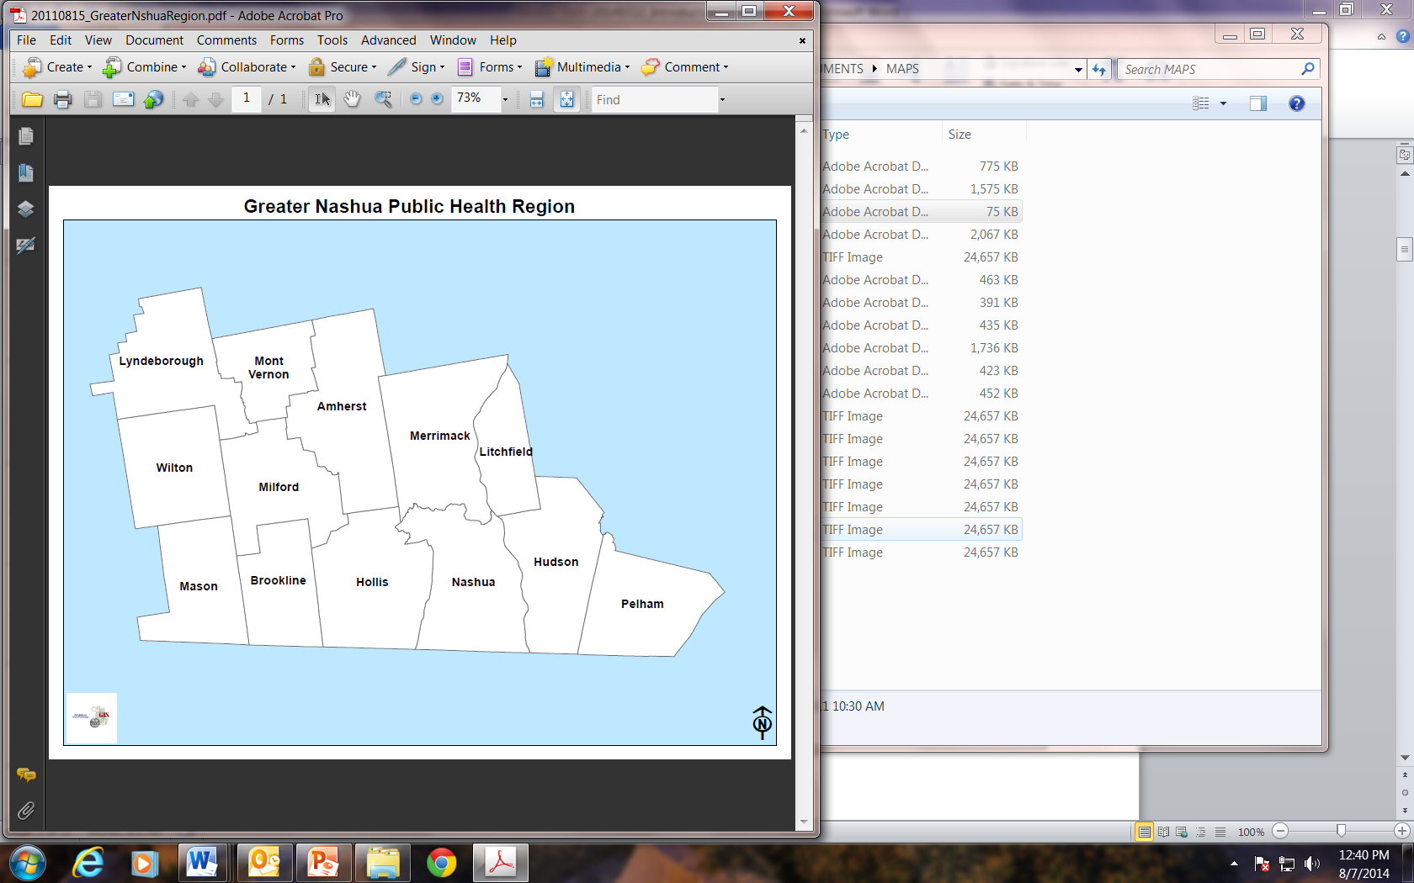

*Source: City of Nashua, Assessing Department*

In 2012, there were a total of 30,000 reported cases in the U.S. This was the highest reported vector-borne illness for that year. In the same year, New Hampshire had the highest incidence rate (incidence = the number of new cases) for Lyme disease. In 2013, the incidence for the state of New Hampshire was 126.7 cases per 100,000 people, the incidence for the GNPHR was 140.6 cases per 100,000 people and the incidence for Nashua was 71.3 per 100,000 people. The incidence in the GNPHR was significantly higher than Nashua (Table 1). In comparison to the counties in New Hampshire, the GNPHR ranks third in incidence for Lyme disease (Figure 2).

For more Lyme disease statistics from the CDC: <http://www.cdc.gov/lyme/stats/index.html>

Figure 2 Incidence Rate of Lyme Disease Cases by Geography, 2013

*Source: NH DHHS*

In 2013, the Greater Nashua Public Health Region had 287 new cases and the City of Nashua had 62 new cases of Lyme disease (Table 1), which accounts for 17% of Lyme cases in New Hampshire.

Table 1 Incidence Rate and Number of Cases of Lyme Disease by Geography, 2013

|  |  |  |  |
| --- | --- | --- | --- |
| Geography | Number of Cases | Rate (per 100,000) | Confidence Interval |
| New Hampshire | 1,687 | 126.7 | 104.6-148.7 |
| Greater Nashua Public Health Region | 287 | 140.6 | 117.4-163.9 |
| Nashua | 62 | 71.3 | 54.8-87.9 |
| *Source: NH DHHS* | | | |

***In 2013, there were 1,687 cases of Lyme disease in New Hampshire.***

***It is most common in kids age’s five to nine and the onset of symptoms is most commonly seen from June to August.***

The incidence rate of Lyme disease has remained consistent over the past five years with the Greater Nashua Public Health Region having a significantly higher rate than the City of Nashua in 2013. In 2012 and 2013, the rate for the region stayed around 140 cases per 100,000 (Figure 3).

Figure 3 Lyme Disease Incidence by Year and Geography, 2008-2013

*Source: NH DHHS*

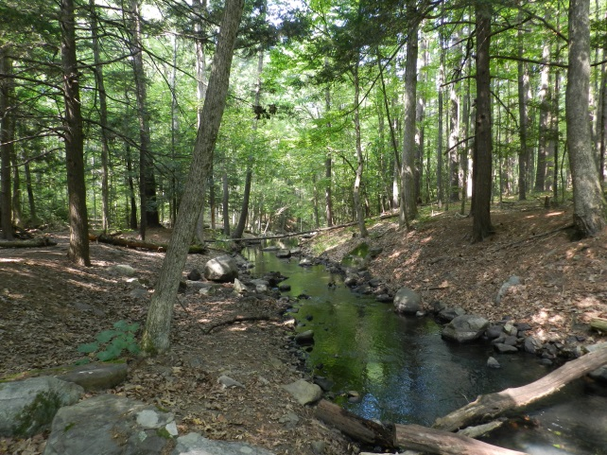Nationally, the onset of symptoms in Lyme disease cases mainly occurs in June, July and August which is a similar pattern to what we see in New Hampshire and the Greater Nashua Public Health Region. In 2013, the highest amounts of Lyme disease cases were in the months of June, July and August for Lyme disease cases in the GNPHR as this is when the blacklegged tick is in the nymph stage (Figure 4).

Figure 4 Epi Curve for Lyme Disease, Greater Nashua Public Health Region, 2013

*Source: NH DHHS*

Lyme disease is most common among boys ages five to nine years of age. In Nashua and the Greater Nashua Public Health Region, the age groups that are most affected are ages five to 14 and 50 to 54 (Figure 4). From 2008-2013, 54.7% of cases in the GNPHR were male.

Figure 4 Rate of Lyme Disease by Age, 2008-2013

*Source: NH DHHS*

# Transmission of Lyme Disease

Blacklegged ticks (Ixodes scapularis and Ixodes pacificus) have a life cycle with four stages which lasts about two years: egg, six-legged larva, eight-legged nymph, and adult (Figures 1, 2). After the eggs hatch, the ticks must have a blood meal at every stage to survive, which means they have to bite a human, animal, reptile, bird or amphibian. Most humans are infected by the nymphs, which are really small and hard to see. They like to feed in the spring and summer. The bacteria that causes Lyme disease, *Borrelia burgdorgeri*, is in the stomach of the blacklegged tick and is spread to humans when the tick bites. Ticks can bite any part of the human body- but tend to prefer the warm areas such as the groin, armpits and scalp. In most cases, in order for the bacteria to be transferred from the tick to the human, the tick must be attached to the body for at least 36 hours. If you remove a tick within 24 hours, you significantly reduce your chances of getting Lyme disease. Ticks like to rest on shrubs and grasses and do not fly or jump. When an animal or human passes by the brush, the ticks can climb on and bite. A blacklegged tick can attach and stay attached for a few days while it feeds.

Figure 5 Stages of blacklegged ticks and size in comparison to a dime

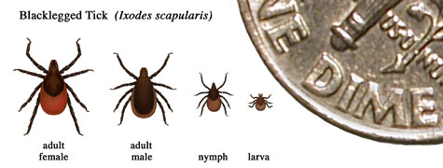

*Source: CDC* [*http://www.cdc.gov/lyme/transmission/blacklegged.html*](http://www.cdc.gov/lyme/transmission/blacklegged.html)

Figure 6 Lifecycle of blacklegged ticks that transmit Lyme Disease

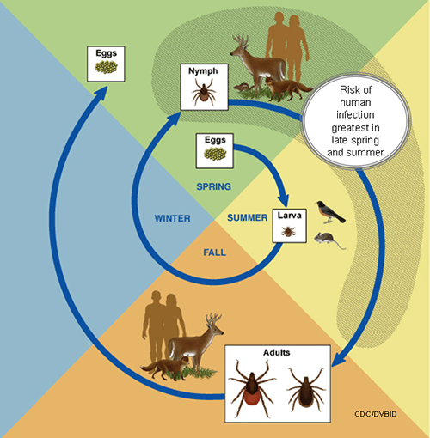

*Source: CDC* [*http://www.cdc.gov/lyme/transmission/blacklegged.html*](http://www.cdc.gov/lyme/transmission/blacklegged.html)

# Frequently Asked Questions about Transmission

**Can I get it from my dog or cat?**

Dogs and cats can get Lyme disease but there is no evidence showing that they can spread the disease to their owners. Protect your pet by using tick control products that are made for pets. Ticks are often brought into the home by the family pet, so frequent tick checks are recommended.

**Can I get it from eating meat, like venison or squirrel meat?**

You cannot get Lyme disease by eating venison or squirrel meat but remember to use good food safety practices such as cooking the meat thoroughly. Ticks may be present on the animal and therefore you should perform a tick check on yourself after handling any game animals.

**Can I get Lyme disease through a blood transfusion?**

There have been no cases of Lyme disease linked to blood transfusions. However, the bacteria that cause Lyme disease can live in blood that is stored for blood donations, so you should not donate blood if you are being treated for Lyme disease.

**Do other ticks transmit Lyme disease?**

Only the blacklegged tick has been associated with Lyme disease in the eastern United States. The Lone star ticks, American dog tick, Rocky Mountain wood tick and the brown dog tick are not known to transmit Lyme disease.

**Can Lyme disease be transmitted person-to-person?**

There is no evidence that Lyme disease can be spread from person-to-person through sexual or any other contact. Because family members usually share the same environment where infected ticks may be present, it is possible for more than one family member to become infected. This does not mean, however, that the disease is spread from person to person.

**I am pregnant and I have Lyme disease. What Should I do?**

If you have been bitten by a tick and think you might have Lyme disease, contact your healthcare provider right away to discuss treatment options. There have been no reports on Lyme disease transmission from breast milk. Antibiotics given to a pregnant woman have not been shown to be harmful to the fetus.

For more information, visit: <http://www.cdc.gov/lyme/transmission/index.html>; <http://www.cdc.gov/lyme/faq/index.html>



# Where and When

Blacklegged ticks are found mainly in the Northeastern Region of the United States, and thus Lyme disease is also found here (Figure 3). These ticks are found in New Hampshire all year long, which means a person can contract Lyme disease from a tick all year long, a fact that few people are aware of. However, Lyme disease is contracted more frequently in the spring and summer months from April to August because this is the time of year when blacklegged ticks are in the nymph stage of their life cycle and are most actively biting and spreading *Borrelia burgdorferi*.

Figure 7 Map of Lyme Disease Cases

**

*Source CDC* [*http://www.cdc.gov/lyme/stats/maps/map2012.html*](http://www.cdc.gov/lyme/stats/maps/map2012.html)

# Signs and Symptoms of Lyme Disease

*If you have any of the following symptoms you should seek medical attention

* Early localized stage (3-30 days after bite)
  + Some people will develop a red expanding bull’s eye shaped rash that may appear anywhere on the body or at the tick bite location, this is called Erythema Migrans (Figure 4)
  + Fatigue (feeling tired), chills, fever, headache, muscle and joint aches, and swollen lymph nodes may also occur
  + Not all people with Lyme disease develop the “bull’s-eye” rash

Figure 8 Erythema Migrans

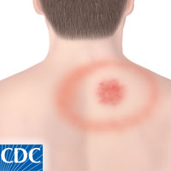

* Early disseminated stage (days to weeks after bite)
  + More erythema migrans may appear on the body
  + Loss of muscle tone on either or both sides of the face called facial palsy (Figure 5)
  + Severe headaches and a stiff neck
  + Pain and swelling in the joints
  + Shooting pains
  + Sudden changes in heartbeat that cause dizziness

Figure 9 Facial palsy

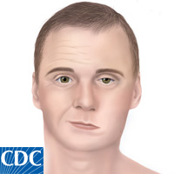

* Late disseminated stage (months to years after tick bite)
  + Swelling of the joints (arthritis)
  + Neurological complaints (tingling in hands or feet, numbness, short-term memory loss, shooting pains)
* Post Treatment Lyme Disease Syndrome
  + Some patients, about 10%, will have symptoms that last months to years even after they have been treated with antibiotics
  + There is some evidence that there may be an autoimmune response where the person’s body is still responding to the infection and causing damage to the tissues in the body
  + Symptoms can include memory loss, loss of focus and muscle and joint pain and fatigue

Nationally, 70% of cases presented with erythema migrans, 31% developed arthritis, and 9% had Bell’s palsy (Figure 10). From 2011-2013, about 60% of Lyme disease cases in the GNPHR had erythema migrans.

Figure 10 Clinical Symptoms of Lyme Disease in the US, 2001-2010

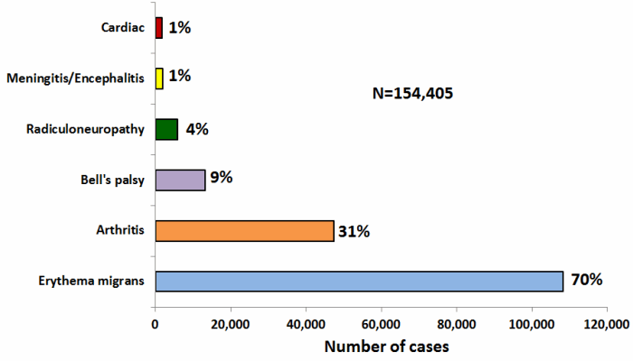

*For more information on symptoms visit: <http://www.cdc.gov/lyme/signs_symptoms/index.html>; <http://www.cdc.gov/lyme/stats/chartstables/casesbysymptom.html>

# Tick Check Instructions

Before going outdoors:

* + Expect ticks if you will be in moist or humid enviroments near wooded or grassy areas
  + Use a repellent containing 20-30% DEET every several hours of being outside, making sure to follow the instructions printed on the label.

After going outdoors:

* + Check all clothing and objects for lingering ticks
  + Shower after coming inside
  + Check your body everywhere making sure not to forget under the arms, in and around the ears, in the belly button, back of the knees, hair and scalp, groin, and around the waist

*For more information: <http://www.cdc.gov/lyme/prev/on_people.html>

# Tick Removal and Disposal

If you find a tick attached to your skin follow these simple steps:

1. Grasp the tick with fine-tipped tweezers as close to the skin as possible.

**Figure 11 Removing a tick**

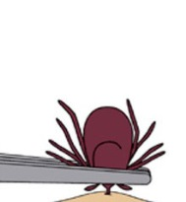

1. Pull outward with steady pressure. Make sure not to twist or jerk the tick.

**Figure 12 Removing a tick**

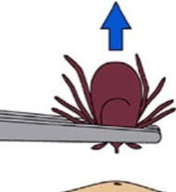

1. Clean the bite area thoroughly and wash your hands using rubbing alcohol, idodine scrub, or soap and water.
2. Dispose of the tick by submersing it in alcohol or flushing it down the toilet.
3. The City of Nashua Division of Public Health and Communitty Services will identify ticks. However, they will not test if they are postive for the bacteria that causes Lyme disease.

*For more information visit [http:// www.cdc.gov/lyme/removal/index.html](http://www.cdc.gov/lyme/removal/index.html)

# Choosing a Repellent

When choosing a repellent to prevent tick bites you’ll want to choose one that contains 20-30% DEET. This carries a scent that deters ticks from biting. You may use repellents containing Picaridin or oil of lemon eucalyptus in replace of DEET. Do not use DEET on children under 2 months of age and do not use oil of lemon eucalyptus on children under 3 years of age. Assist children with applying repellent and do not put it on their hands, eyes or mouth. Clothing and gear such as tents can be treated with 0.05% permethrin.

* For more information visit <http://www.cdc.gov/ticks/avoid/on_people.html>
* For more information on repellents and kids, visit: <http://www.healthychildren.org/English/safety-prevention/at-play/Pages/Insect-Repellents.aspx>
* For more information on repellents visit <http://cfpub.epa.gov/oppref/insect/>

