Resources for Community Wide Initiatives

State Resources, Statistics and Information 2
New Hampshire Department of Health and Human Services 2
Lyme Disease Fact Sheet: 4
University of New Hampshire 5
The Connecticut Agricultural Experiment Station, The Connecticut General Assembly 6
Online Resources for Ordering Lyme Prevention Materials 7
Centers for Disease Control and Prevention Info (CDC_INFO) On Demand 7
Tick Encounters Shower Card 8
Social Media Blurb: Facebook, Twitter, Etc. 10
Tips 10
Facebook Posts 10
Twitter Posts 10
Widgets 11
Template Newsletter Article 12
Distributable E-mail 13
Checklist for Creating a Tick Free Space 14
Before and After Pictures of Lawns Controlled for Ticks 15
CDC Pamphlet (PDF) 16
Trail Sign 17
Lyme Disease PowerPoint 18

State Resources, Statistics and Information

New Hampshire Department of Health and Human Services
- Lyme and other Tick-borne Diseases: http://www.dhhs.nh.gov/dphs/cdcs/lyme/ 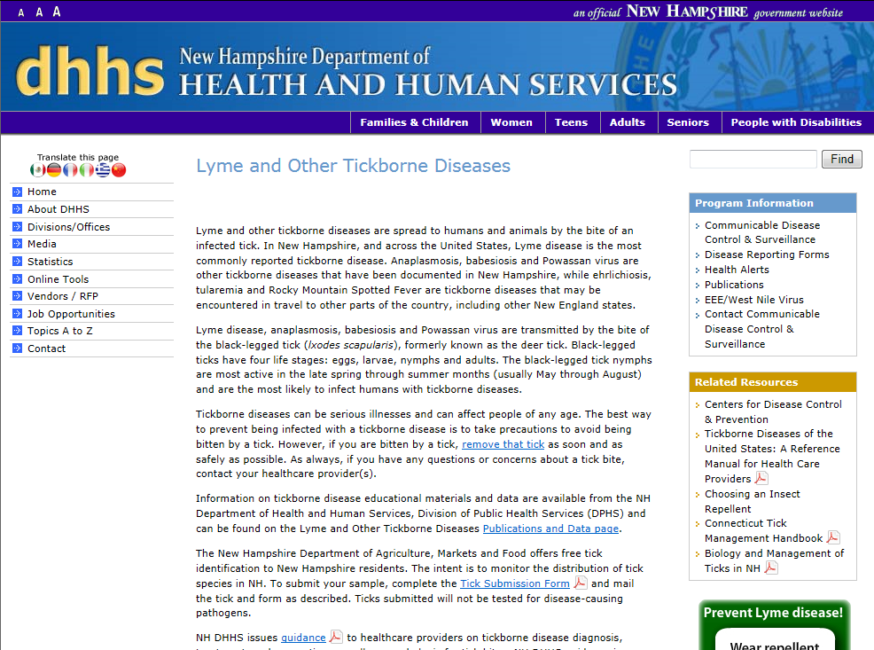

Over 60% of ticks in Hillsborough County have tested positive for the bacteria that causes Lyme disease

- Lyme Disease Data: http://www.dhhs.state.nh.us/dphs/cdcs/lyme/publications.htm

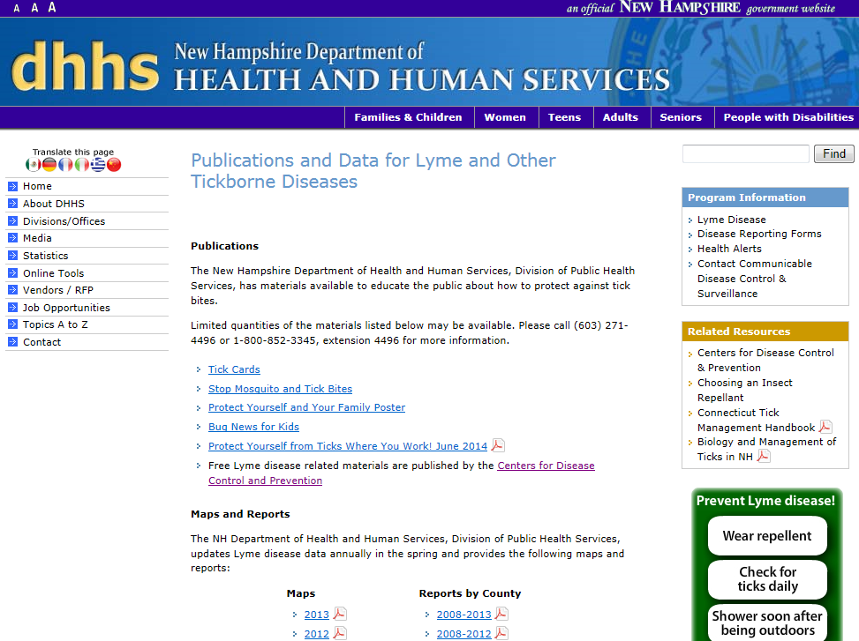

Lyme Disease Fact Sheet:
This fact sheet provides quick answers to all of the basic questions that one needs to know about Lyme disease in two pages. This fact sheet could be placed in public bulletin boards for employees/ patrons to read.
http://www.dhhs.nh.gov/dphs/cdcs/lyme/documents/lyme.pdf

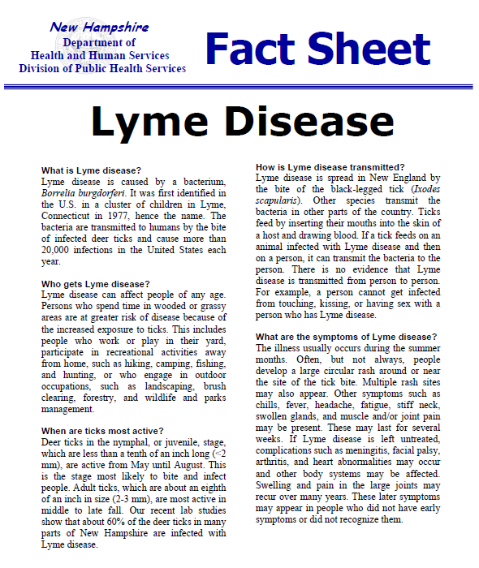

University of New Hampshire
- Biology and Management of Ticks in New Hampshire: http://extension.unh.edu/resources/files/Resource000528_Rep1451.pdf
  - The University of New Hampshire produced this resource in order to help you learn what ticks look like, how they live, what diseases they spread and how to prevent these diseases.

The Connecticut Agricultural Experiment Station, The Connecticut General Assembly
- Tick Management Handbook: http://www.ct.gov/dph/lib/dph/infectious_diseases/lyme/TickManagementHandbook2007.pdf
  - This is a guide for homeowners, pest control operators and public health officials on how to prevent tick-borne diseases. It was drafted by the Connecticut General Assembly to be used as a guide in preventing tick-borne diseases.
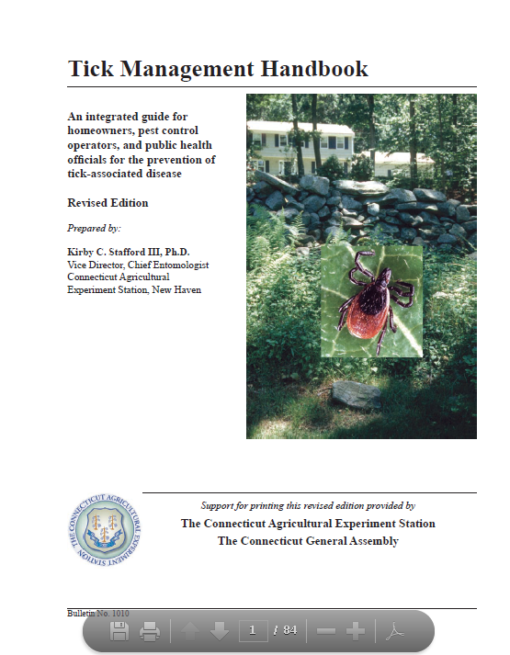

Online Resources for Ordering Lyme Prevention Materials

Centers for Disease Control and Prevention Info (CDC_INFO) On Demand
- Order or download books, fact sheets, pamphlets, and educational materials
- Search for “Vector-borne Diseases” or “Vector-borne Diseases – Lyme Disease”
- Website: http://wwwn.cdc.gov/pubs/CDCInfoOnDemand.aspx
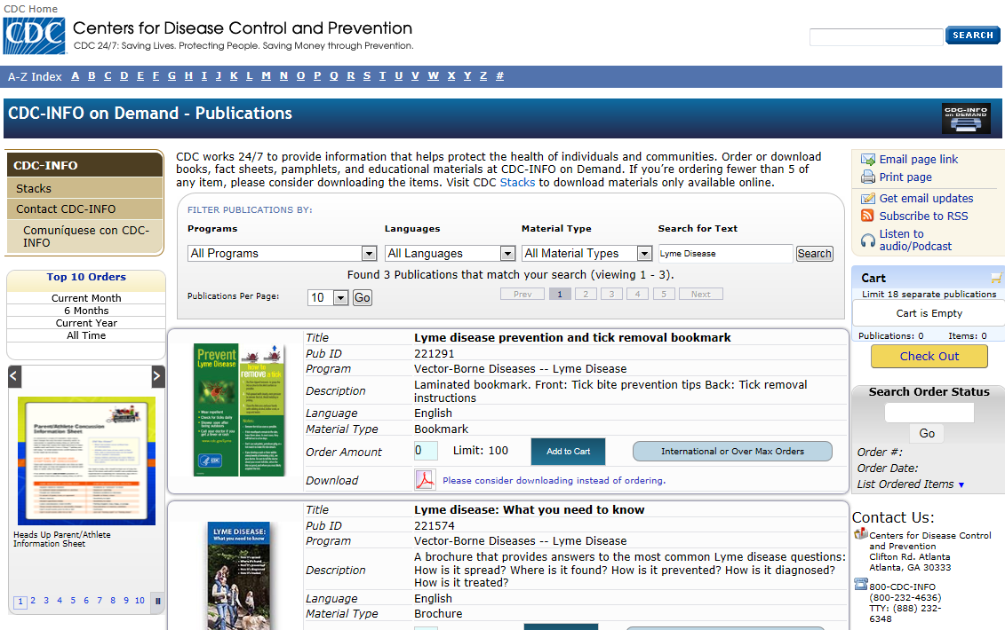

Tick Encounters Shower Card
- You can purchase this shower card and place it in your shower as a reminder of how to check yourself properly for ticks
- Website: http://www.tickencounter.org/tepp/dailytickcheck_showercards
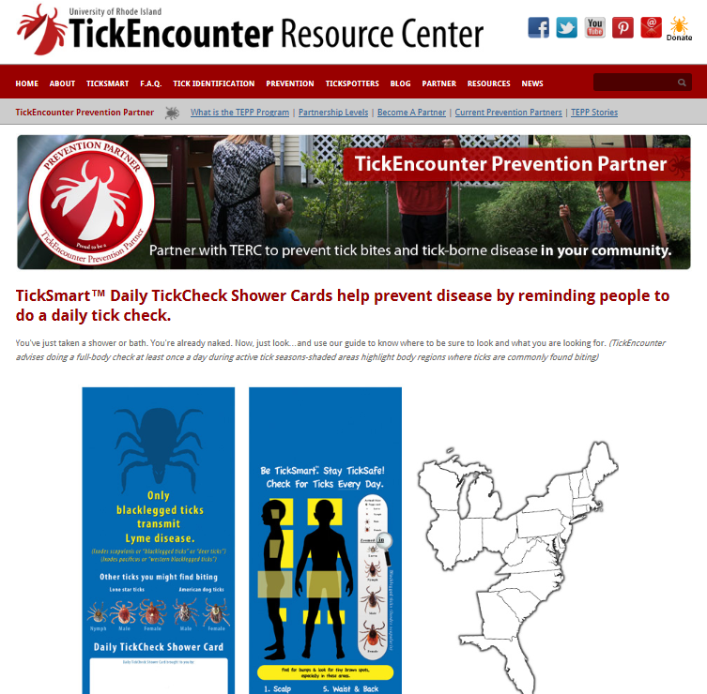
Tick Check Diagram
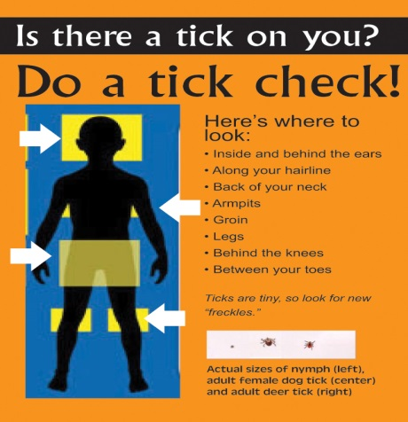
Source: http://extension.missouri.edu/news/DisplayStory.aspx?N=2001

Social Media Blurb: Facebook, Twitter, Etc.

Tips
When posting to social media it is best to keep things simple and include capturing images with links to credible information. With each of the posts below include http://www.cdc.gov/lyme/ as well as an image that you think would capture attention such as the one below.
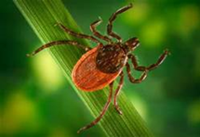
Source: http://s3.hubimg.com/u/6902862_f496.jpg

Facebook Posts
“Lyme Disease is on the rise and the best way to avoid it is preventing it! Remember to check for ticks everywhere after going outside… Don’t forget to check your furry friends too!”
“60% of ticks in NH carry Lyme disease- always check yourself and others for poppy seed sized ticks after being outside”.
“We want you to know that Lyme disease is a serious problem in our region. Beware of ticks outdoors and remember to check for ticks after being outside”.

Twitter Posts
“Spring and summer are here! Watch out for ticks and make sure to check yourself!”
“If you’re going outside keep ticks in mind! The best way to stop Lyme disease is to prevent it!”
“Stop Lyme disease by wearing repellent, wearing the proper clothing and checking yourself!”

Widgets
To add a widget on Lyme disease to your website, visit the CDC Lyme Disease Toolkit website at: http://www.cdc.gov/lyme/toolkit/index.html
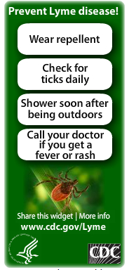

Template Newsletter Article

Lyme disease is caused by a bacteria called Borrelia burgdorferi, which is transmitted to humans through the bite of infected blacklegged ticks, also known as blacklegged tick ticks. In 2012, New Hampshire was reported to have the highest incidence of Lyme disease in the United States, and in recent years, Hillsborough and Rockingham counties have accounted for nearly 70% of all confirmed Lyme cases in New Hampshire. However, proper education and prevention can help reduce the number of Lyme disease cases.
The blacklegged tick is most active from early spring to late fall, but preventative measures should be taken year round. If you are planning on spending time outdoors then remember to wear a good repellant, such as one containing DEET. The CDC recommends a repellant containing 20-30% DEET on exposed skin and clothing, as DEET can be effective for several hours at this concentration. It is equally important to reapply the repellant as needed by following the product instructions. Parents should apply repellants containing 20-30% DEET to their children and make sure to avoid the hands, eyes, and mouth. DEET shouldn’t be applied to babies under 2 months of age. Light colored clothing should be worn to easily spot ticks, and pants should be worn and tucked into socks to prevent ticks from crawling up the legs. When hiking, remember to stay on established paths, as this reduces your chance to encounter ticks. Check for ticks on your body, and be mindful of hard to see places such as armpits, scalp, groin, and the back of knees. After coming indoors, take a shower to wash away any ticks that may be crawling on you, and if any ticks are found on you, or your clothing, put your clothes in the dryer under high heat for 60 minutes to kill any remaining ticks.
For more information on Lyme disease, tick removal, and prevention methods for pets and backyards please visit the CDC’s website on Lyme disease at cdc.gov/lyme. The Nashua Environmental Health Department is also available to identify ticks and answer any questions you may have. The Nashua Environmental Health Department can be reached Monday through Friday 8AM-5PM at 603-589-4530.

Distributable E-mail

Subject- Spring is Here, Let’s Prevent Lyme Disease!
Text-
Hello,
With the nice weather right around the corner, we would like to share some tips on preventing Lyme Disease!
- Try to avoid walking in the deep woods or bushy tall grass areas and walk in the middle of all paths
- Check yourself and kids for ticks in the shower after each time you are outside for a prolonged period of time (don’t forget the groin, scalp and armpits)
- Check pets for ticks frequently
- Wear long sleeves and pants along with bug spray containing at least 20% DEET.
In the event that you do find a tick on yourself or others, you can remove it by finding a pair of fine tipped tweezers, gripping the tick as close to the skin as possible, and pulling straight away from the body, making sure not to twist the tick. If you found and removed a tick that may have been attached for 36 hours or longer, contact your healthcare provider and watch for a “bulls eye” looking rash or flu-like symptoms. If you experience these, you should consult a healthcare provider, making sure to inform them that you have been bitten by a tick. For more information, you can visit the Centers for Disease Control and Prevention website (http://www.cdc.gov/lyme/) or call the City of Nashua, Enivromental Health Department at (603) 589-4530.

Checklist for Creating a Tick Free Space
- Clear tall grasses and brush around buildings and at the edges of the playground or yard
- Place a 3ft wide barrier of wood chips and gravel between the edge of the playground or yard and the woods as well as around all play equipment
- Maintain the playground by mowing the lawns, raking up leaf litter and removing all trash
- Remove any tick breeding grounds such as old mattresses, furniture or cars from the playground or yard
- Keep all play equipment away from the edges of wooded areas
- Keep all tick carriers such as mice, deer and stray dogs out of the playground or yard
- Safely spray a small amount of acaricide once every May or June around the border of the playground or yard to keep ticks away
*For more information visit http://www.cdc.gov/ticks/avoid/in_the_yard.html
Source: http://www.ct.gov/caes/lib/caes/documents/special_features/tickhandbook.pdf

Before and After Pictures of Lawns Controlled for Ticks
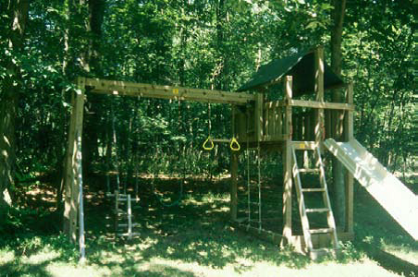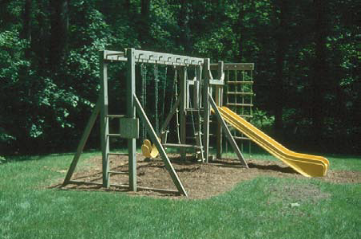
Source: http://www.ct.gov/caes/lib/caes/documents/special_features/tickhandbook.pdf
If you think you may have contracted or become infected with Lyme disease, contact your healthcare provider to discuss treatment options as soon as possible.

CDC Pamphlet (PDF)
- A pamphlet containing information on how Lyme disease is spread, where it is found, how it is prevented, how it is diagnosed and how it is treated.
- http://www.cdc.gov/lyme/resources/brochure/lymediseasebrochure.pdf

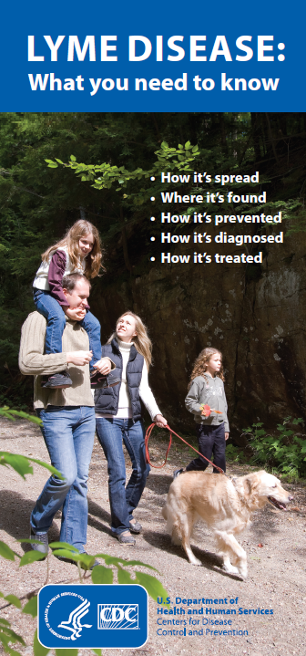

Trail Sign
- Post this trail sign in parks, trails, playgrounds, schools, camps, backyards and any area outdoor area that may have ticks. PDF of Trail Sign:
http://www.cdc.gov/lyme/resources/toolkit/2%20Color%20Trail%20Sign.pdf
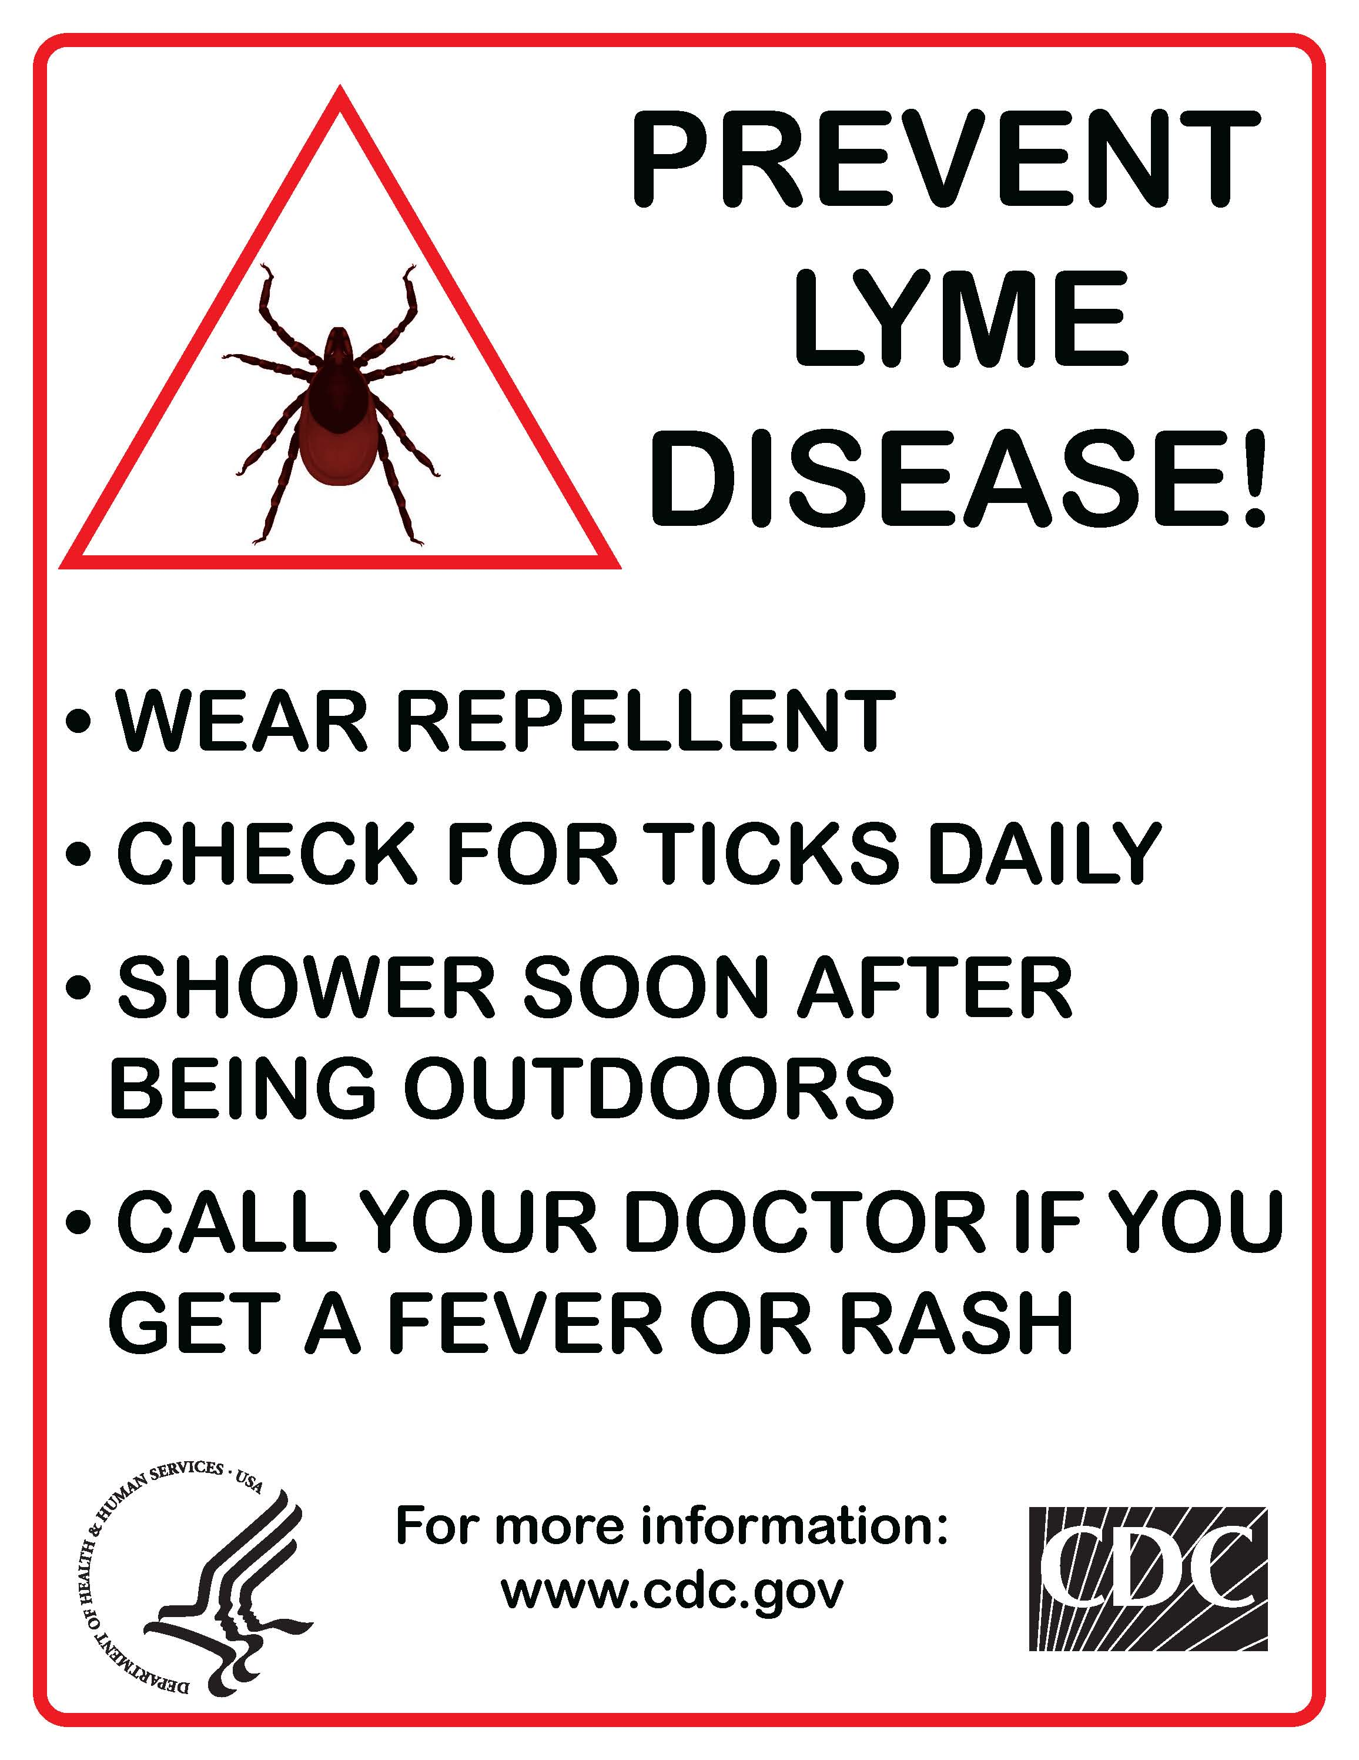

Lyme Disease PowerPoint
- A brief PowerPoint that can be presented in a quick meeting or sent via email. This can be downloaded from the City of Nashua, Division of Public Health and Community Services website at: http://bit.ly/nashuahealtheducation

