Resources for Schools, Childcare Centers and Camps

Lyme Disease Fact or Fiction for Teens 2
Lyme Disease Prevention Checklist for Schools, Universities, Summer Camps and Childcare Centers 4
Lyme Disease Poster and Bookmarks (PDF) 7
Coloring Pages and Word Search (PDF) 8

Lyme Disease Fact or Fiction for Teens
http://www.cdc.gov/lyme/quiz/q2/index.html
Instructions:
Below is a list of true/false statements about Lyme disease. Read aloud each statement to the class and ask if they think it is true or false.
The answers for each statement are below.
- Lyme disease was first discovered in Lyme, New Hampshire. F
False: Lyme disease only became apparent in 1975 when mothers of a group of children who lived near each other in Lyme, Connecticut, made researchers aware that their children had all been diagnosed with rheumatoid arthritis. This unusual grouping of illness that appeared "rheumatoid" eventually led researchers to the identification of the bacterial cause of the children's condition, which was then called "Lyme disease" in 1982.
- Lyme disease occurs throughout the United States. F
False: Although Lyme disease cases have been reported from all 50 states, these reports reflect where the patient lives, which is not necessarily where he or she became infected. In truth, infected ticks of the type that transmit Lyme disease are not found in many states. In the states without infected ticks that spread Lyme disease, infections are usually the result of travel to a state where the disease is common, especially states in the northeast and upper Great Lakes regions. Ticks transmit diseases other than Lyme disease, so you should know how to protect yourself no matter where you live.

- Lyme disease is transmitted from person to person. F
False: The only proven means of Lyme disease transmission is through the bite of a Borrelia burgdorferi infected tick. Although you may have heard that Lyme disease can be transmitted from person to person through breast milk or sexual contact, there is no scientific evidence for either of these routes.
The ticks that transmit Lyme disease are very small and often go unnoticed. Because family members usually share the same environment where infected ticks may be present, it is possible for more than one family member to become infected. This does not mean, however, that the disease is spread from person to person.
- The best way to remove an attached tick is by applying petroleum jelly. F
False: Grasp the tick close to the skin with tweezers and pull straight away from the skin. Do not burn off or use other homeopathic methods such as applying nail polish or petroleum jelly as they may actually cause transmission of Lyme disease.
- A tick must be attached to a person’s skin for more than 24 hours before it can transmit Lyme Disease. T
True: Ticks that transmit Lyme disease can take 3 or more days to feed fully. If the tick is infected, the chance of transmission increases the longer that the tick remains attached to the person. Therefore, it is important to conduct tick checks after working or recreating in tick infested areas, and promptly removing any ticks you find.

Kids 5-9 years old have the highest number of cases of Lyme disease nationwide- education and prevention are our best tools to stop early age Lyme.

Lyme Disease Prevention Checklist for Schools, Universities, Summer Camps and Childcare Centers

Use this tool to determine which actions you already take to promote Lyme disease prevention and which actions you can take at your organization. Place an “x” in the appropriate column as you fill out the checklist. For actions you want to consider implementing, identify the appropriate person in your organization that can complete the action and assign a timeline for completing the action.
Action Item | Already Being Done | Consider Implementing (Identify Lead for Action) | Not Applicable to my organization
Review the Lyme Prevention Toolkit for information and to become familiar with available resources |  | N/A | N/A
Education
Post prevention tips on Facebook, Twitter and other social media sites  - Reference the Toolkit Resources – General Information Section for a template |  | Lead:  Deadline:
Hang up posters that promote tick checks and insect repellants near exits to the facility and near playgrounds, trails and fields |  | Lead:  Deadline:
Sent an email blast to parents, teachers, faculty and students (university level students) with information that promotes prevention  - Reference the Toolkit Resources – General Information Section for a template |  | Lead:  Deadline:
Put information on prevention in your quarterly newsletter  - Reference the Toolkit Resources – General Information Section for a template |  | Lead:  Deadline:
Put table tents with information on prevention in the cafeteria |  | Lead:  Deadline:
Include components of prevention into the curriculum or camp program  - For example, if a class is being taught about ecosystems, include a segment on tickborne diseases and promote prevention |  | Lead:  Deadline:
Post Lyme disease quiz to scrolling PowerPoint or TV screen in the cafeteria or waiting areas
- Reference the Toolkit – Schools/Camps section
Educate trainers, athletic directors and coaches on prevention measures for athletes |  | Lead:  Deadline:
Educate maintenance and landscaper staff on prevention measures and make insect repellant available |  | Lead:  Deadline:
Educate individuals on areas where ticks have commonly been found |  | Lead:  Deadline:
Educate parents on Lyme disease and how to check their kids for ticks |  | Lead:  Deadline:
Prevention
Promote the use of insect repellant to faculty, staff, children, students and parents prior to playing outdoors, playing sports or going for a hike |  | Lead:  Deadline:
Make insect repellant available for parents, campers, students, children, faculty and staff  - Reference the Introduction for choosing insect repellants |  | Lead:  Deadline:
Check students, children, campers, faculty and staff for ticks on their head/hairline and clothes when they are done playing outside or done hiking |  | Lead:  Deadline:
When taking students and campers hiking, stay in the middle of the path and avoid going into brush |  | Lead:  Deadline:
Prior to going on a hike or playing near brush and wooded areas, ask parents to dress kids/campers in light clothing so you can easily check for ticks |  | Lead:  Deadline:
Prior to athletic games, promote the use of insect repellant to players |  | Lead:  Deadline:
Report found ticks to the appropriate staff member
Maintain a log of where all ticks have been found on site to keep track of where ticks are most frequent |  | Lead:  Deadline:
Tick Control in Fields, Playgrounds and Yards
Clear tall grasses and brush around buildings and at the edges of the playground or yard |  | Lead:  Deadline:
Place a 3ft wide barrier of wood chips and gravel between the edge of the playground or yard and the woods as well as around all play equipment |  | Lead:  Deadline:
Maintain the playground by mowing the lawns, raking up leaf litter and removing all trash |  | Lead:  Deadline:
Remove tick breeding grounds such as old mattresses, furniture or cars from the playground or yard |  | Lead:  Deadline:
Keep all play equipment away from the edges of wooded areas |  | Lead:  Deadline:
Keep all tick carriers such as mice, deer and stray dogs out of the playground or yard |  | Lead:  Deadline:
Consider safely spraying a small amount of acaricide once every May or June to keep ticks away |  | Lead:  Deadline:
Situational Awareness
Check the CDC website at www.cdc.gov each spring for new information or educational materials that can be used |  | Lead:  Deadline:
Check the NH DHHS website at http://www.dhhs.state.nh.us/ |  | Lead:  Deadline:

Lyme Disease Poster and Bookmarks (PDF)
- Bookmark: http://www.cdph.ca.gov/HealthInfo/discond/Documents/Ticksbookmark.pdf
  - This bookmark can be handed out to children and students to use in their daily reading books. It gives easy and helpful information for kids on how to be aware of ticks, prevent being bitten and removing ticks safely.
- Poster: http://www.cdph.ca.gov/HealthInfo/discond/Documents/Dontlettheticksbite.pdf
  - This poster is designed for kids and can be hung on school/camp bulletin boards. It offers easy to read information on ticks and Lyme disease and contains engaging pictures for children.
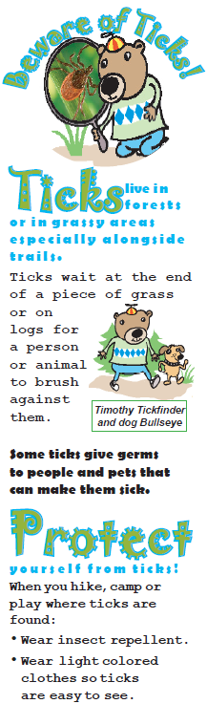
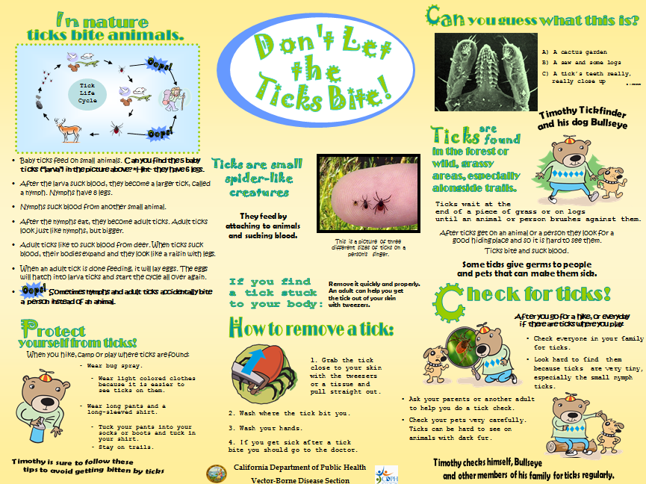

Coloring Pages and Word Search (PDF)
- Coloring Pages: http://www.cdph.ca.gov/HealthInfo/discond/Documents/TimothyTickfinderColoringPages.pdf
  - This coloring page can be used in classroom downtime or on a rainy day at camp to promote Lyme disease awareness amongst kids.
- Word Search: http://www.cdph.ca.gov/HealthInfo/discond/Documents/DLTTBWordSearch.pdf
  - This word search can be used as an educational material for kids in conjunction with other materials provided in this section of the toolkit to promote Lyme disease awareness amongst kids.
