Resources for Families and Individuals with Pets

Pets and Ticks 2
Reducing the Risk of Transmission to pets 2
CDC Guides for Parents: 3
CDC Guide for Pregnant Women 4
CDC Crossword Puzzle for Kids 6

Pets and Ticks
Pets are extremely susceptible to tick bites and tick-borne diseases when they go outside. They also make great “vehicles” for ticks to access a home

Reducing the Risk of Transmission to pets
- Check your pets daily for ticks, especially after being outside
- Remove any ticks immediately
- Watch for behavioral changes in your dog such as decreased appetite, limping and an increase in lethargy
- Ask your veterinarian to check for ticks at each exam
- Follow the steps to reducing ticks in your yard listed in the Resources for Community Wide Initiatives section of this toolkit
- Talk to your veterinarian about using tick preventatives, such as permethrin, on your pets
- If approved by a veterinarian use acaricides on dogs with caution
  - Cats are very sensitive to chemicals so always consult a veterinarian about using tick repellents on cats
*For more information: http://www.cdc.gov/lyme/prev/on_pets.html

CDC Guides for Parents:
English:
Lyme Disease Guide for Parents
http://www.cdc.gov/lyme/resources/toolkit/factsheets/10_508_Lymedisease_Parent.pdf

Spanish:
Guía de la enfermedad de Lyme para los Padres
http://www.cdc.gov/lyme/resources/toolkit/factsheets/10_508_Lymedisease_Parent_SPANISH.pdf

Portuguese:
Guia da doença de Lyme para Pais
http://www.cdc.gov/lyme/resources/toolkit/factsheets/10_508_ChildrenLymedisease_BrazilianPortuguese_FACTSheet.pdf
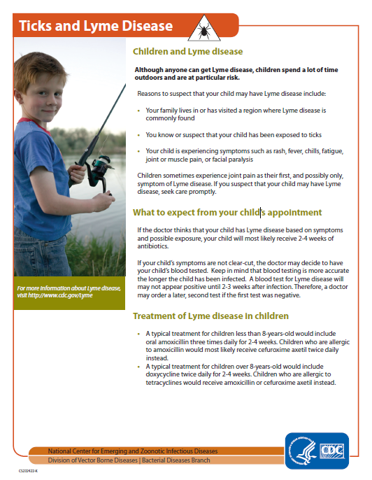

CDC Guide for Pregnant Women
English:
Lyme Disease and Pregnancy
http://www.cdc.gov/lyme/resources/toolkit/factsheets/10_508_Lyme%20disease_PregnantWoman_FACTSheet.pdf

Spanish:
Enfermedad de Lyme y el Embarazo
http://www.cdc.gov/lyme/resources/toolkit/factsheets/10_508_Lyme%20disease_PregnantWoman_FACTSheet_SPANISH.pdf
Portugese:
Doença de Lyme e Gravidez
http://www.cdc.gov/lyme/resources/toolkit/factsheets/10_508_Lymedisease_PregnantWoman_BrazilianPortuguese_FACTSheet.pdf
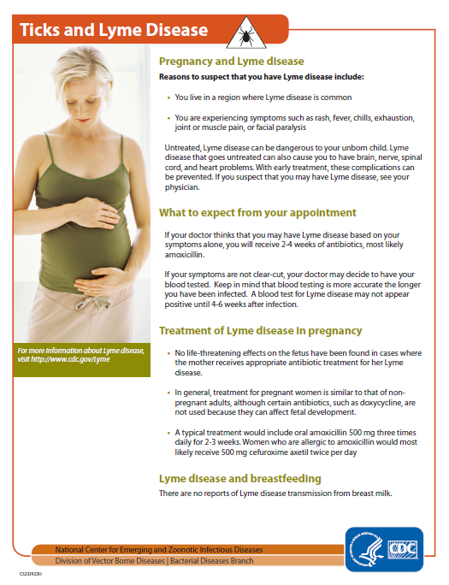

CDC Crossword Puzzle for Kids
- http://www.cdc.gov/lyme/resources/toolkit/Final_LymeDiseaseCrossword_apr2010.pdf
  - This crossword puzzle contains brief information on what ticks are, where they live and how to find them on your body. It can be completed with kids while talking about Lyme disease and the preventative methods listed throughout this toolkit that the family can take to reduce tick bites in the home
