Resources for Employers and Employees

Occupations at Risk 2
Recommendations for Employees 2
Recommendations for Employers 3
NHDHHS Protect Yourself Where You Work 4
CDC Guide for Outdoor Workers 5
Lyme Disease Prevention Checklist for Employers 6

Occupations at Risk
The following is a list of occupations that commonly see employees reporting cases of Lyme disease:
- Construction
- Landscaping
- Forestry
- Brush clearing
- Land surveying
- Farming
- Railroad work
- Oil field work
- Utility line work
- Park or wildlife management
- Other outdoor work

Recommendations for Employees
The following are steps that employees can use to prevent contracting Lyme disease at work:
- Wear a hat and light-colored clothing that includes long-sleeved shirts and pants tucked into boots or socks
- Use insect repellents that provide long lasting protection
  - Make sure to use repellents that contain 20-30% DEET
  - Follow directions on label properly
- Use insecticides such as Permethrin for greater protection
- Check skin and clothes for ticks during breaks, at lunch and after work
- Place clothes in a hot dryer to destroy any missed ticks
- Learn the symptoms of Lyme disease
  - Seek medical attention if you believe you may have Lyme disease or if you believe a tick has been attached for longer than 24 hours.
*For more information: http://www.cdc.gov/niosh/topics/lyme/

Recommendations for Employers
The following are steps that employers can take to create a more informed and safe workplace
- Provide training for staff members that includes information about
  - The spread of Lyme disease
  - Risks of exposure to Lyme disease
  - How to protect yourself
  - How to report illnesses in the workplace
- Advise workers to wear light-colored, long-sleeved shirts, long pants, socks, and a hat
- Provide workers with insect repellents containing 20-30% DEET
- Have workers avoid working at sites with woods, bushes, tall grass, and leaf litter whenever possible
- When not possible: remove leaf litter, mow lawns and brush and control all rodent and deer activity
*For more information: http://www.cdc.gov/niosh/topics/lyme/

Source: http://www.sciencephoto.com/image/434040/530wm/F0043511-Workers_talking_at_construction_site-SPL.jpg

NH DHHS Protect Yourself Where You Work
http://www.dhhs.nh.gov/dphs/hsdm/ohs/documents/ticksbrief0614.pdf
This is an issue brief on tick-borne diseases designed for outdoor workers, supervisors and safety personnel.
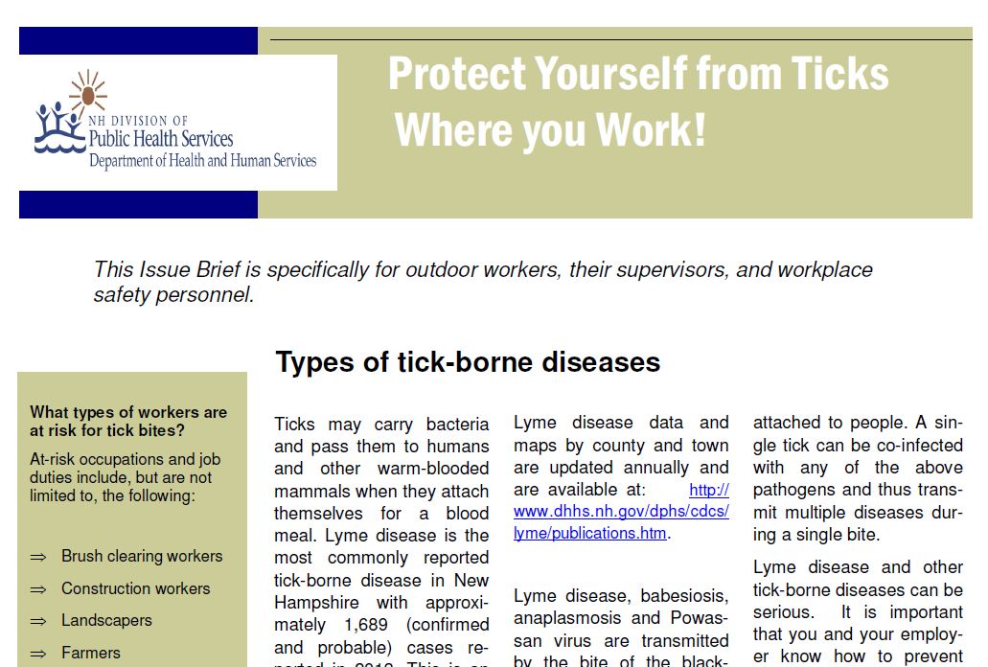

CDC Guide for Outdoor Workers
English:
Lyme Disease and Outdoor Workers
http://www.cdc.gov/lyme/resources/toolkit/factsheets/10_508_Lyme%20disease_Outdoorworkers_FACTSheet.pdf

Spanish:
Enfermedad de Lyme y trabajan al aire libre
http://www.cdc.gov/lyme/resources/toolkit/factsheets/10_508_Lyme%20disease_Outdoorworkers_FACTSheet_Spanish.pdf

Portuguese:
Doença de Lyme e trabalhadores ao ar livre
http://www.cdc.gov/lyme/resources/toolkit/factsheets/10_508_Lymedisease_BrazilianPortuguese_FACTSheet.pdf
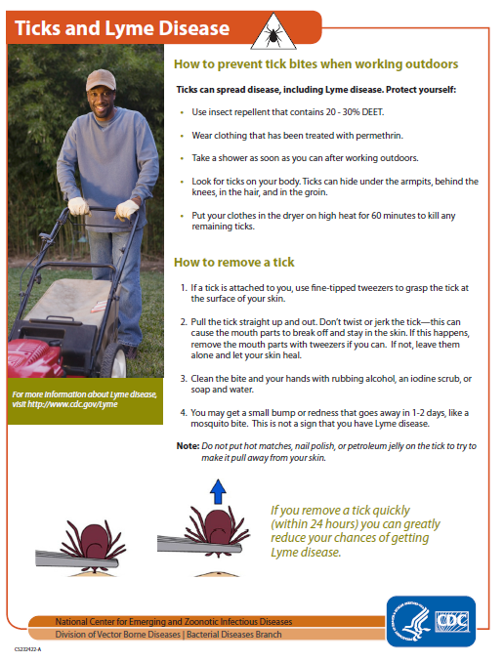

Lyme Disease Prevention Checklist for Employers
Use this tool to determine which actions you already take to promote Lyme disease prevention and which actions you can take at your organization. Place an “x” in the appropriate column as you fill out the checklist. For actions you want to consider implementing, identify the appropriate person in your organization that can complete the action and assign a timeline for completing the action.

Action Item | Already Being Done | Consider Implementing (Identify Lead for Action) | Not Applicable to my organization
Review the Lyme Prevention Toolkit for information and to become familiar with available resources |  | N/A | N/A
Education
Post prevention tips on Facebook, Twitter and other social media sites  - Reference the Toolkit Resources – General Information Section for a template |  | Lead:  Deadline:
Hang up posters that promote tick checks and insect repellants near exits to the facility and near fields |  | Lead:  Deadline:
Sent an email blast to staff with information that promotes prevention  - Reference the Toolkit Resources – General Information Section for a template |  | Lead:  Deadline:
Put information on prevention in your quarterly newsletter  - Reference the Toolkit Resources – General Information Section for a template |  | Lead:  Deadline:
Put table tents with information on prevention in the cafeteria |  | Lead:  Deadline:
Include components of prevention into staff training |  | Lead:  Deadline:
Post Lyme disease quiz to scrolling PowerPoint or TV screen in the cafeteria or waiting areas
- Reference the Toolkit – Schools/Camps section
Educate staff and workers on prevention measures |  | Lead:  Deadline:
Tick Control Environment near the Facility
Clear tall grasses and brush around buildings |  | Lead:  Deadline:
Place a 3ft wide barrier of wood chips and gravel between the edge of the woods and the grounds |  | Lead:  Deadline:
Maintain the grounds by mowing the lawns, raking up leaf litter and removing all trash |  | Lead:  Deadline:
Remove tick breeding grounds such as old mattresses, furniture or cars from the grounds |  | Lead:  Deadline:
Keep all tick carriers such as mice, deer and stray dogs out of the grounds |  | Lead:  Deadline:
Consider safely spraying a small amount of acaricide once every May or June to keep ticks away |  | Lead:  Deadline:
Situational Awareness
Check the CDC website at www.cdc.gov each spring for new information or educational materials that can be used |  | Lead:  Deadline:
Check the NH DHHS website at http://www.dhhs.state.nh.us/ for new information on Lyme disease in New Hampshire |  | Lead:  Deadline:

