Resources for Golfers and Hikers

CDC Guide for Golfers 2
CDC Guide for Hikers 3

CDC Guide for Golfers
English: http://www.cdc.gov/lyme/resources/toolkit/factsheets/Golfing_English.pdf
Spanish: http://www.cdc.gov/lyme/resources/toolkit/factsheets/Golfing_Spanish.pdf
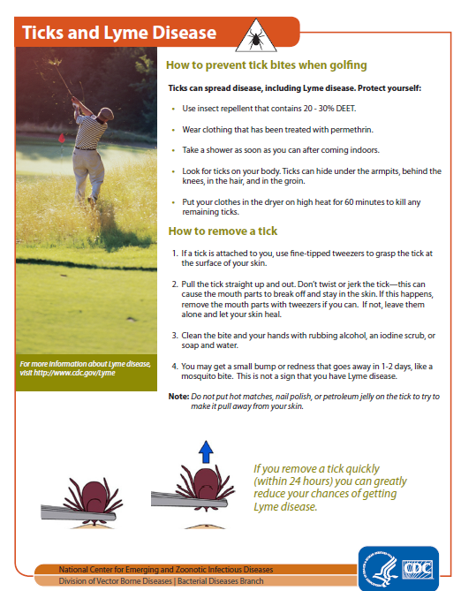

CDC Guide for Hikers
English: http://www.cdc.gov/lyme/resources/toolkit/factsheets/10_508_Lyme%20disease_HikersCampers_FACTSheet.pdf
Spanish: http://www.cdc.gov/lyme/resources/toolkit/factsheets/11_222447A_Lymedisease_HikerCamper_FACTSht_Spanish.pdf

