Resources for Healthcare Professionals

Reporting a Lyme Disease Case in New Hampshire 2
New Hampshire Health Alert Network (HAN) Messages 4
Tick-borne Diseases of the United States: A Reference Manual for Health Care Providers 5
Centers for Disease Control and Prevention Resources for Clinicians 6
2006 IDSA Treatment Guidelines 7
Continuing Medical Education for Clinicians 8
Lyme Disease Self -Assessment 8

Reporting a Lyme Disease Case in New Hampshire
Lyme disease is one of the many required reportable diseases in New Hampshire. To report a reportable disease to the New Hampshire Department of Health and Human Services, call 603-271-4496 or 1-800-852-3345 ext. 4496. After hours, call 603-271-5300 or 1-800-852-3345 ext. 5300. Forms can be faxed to 603-271-0545. Reports can be mailed to:

NH Department of Health and Human Services
Division of Public Health Services
Communicable Disease Control and Surveillance
29 Hazen Drive, Concord, NH 03301-6504
Lyme Reporting Form for NH:
http://www.dhhs.nh.gov/dphs/cdcs/documents/lymediseasereport.pdf
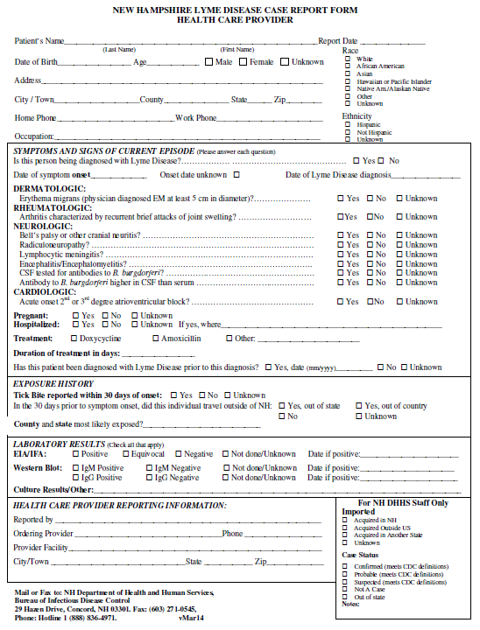
Complete list of Reportable Diseases:
http://www.dhhs.nh.gov/dphs/cdcs/documents/reportablediseases.pdf

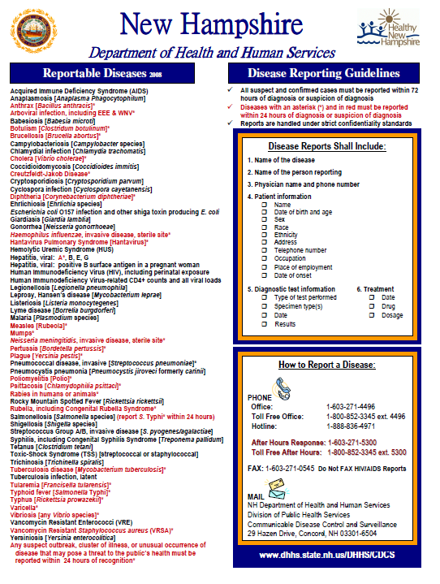

New Hampshire Health Alert Network (HAN) Messages
The NH DHHS utilizes the NH Health Alert Network to provide timely messages to Healthcare providers. The NH Health Alert Network (NH HAN) is a 24/7/365 comprehensive system for public health emergency notifications and alerts in response to events or incidents of public health significance. It includes a network of individuals and the software and hardware needed to create messages and respond to communications around public health incidents. For more information on receiving Health Alerts, contact the NH HAN Lyme Coordinator at Health.Alert@nh.gov.
- General Information on HAN: http://www.dhhs.nh.gov/dphs/cdcs/alerts/
- To access archived HAN messages: http://www.dhhs.nh.gov/dphs/cdcs/alerts/han.htm
- NH DHHS Tick-borne Disease Guidance from 2014: http://www.dhhs.nh.gov/dphs/cdcs/alerts/documents/lymedisease-2014.pdf
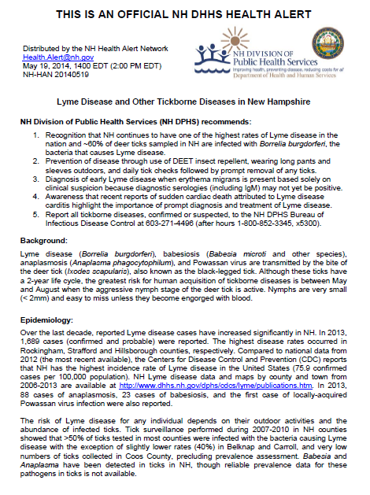

Tick-borne Diseases of the United States: A Reference Manual for Health Care Providers
- http://www.cdc.gov/lyme/resources/TickborneDiseases.pdf
  - This manual can be used by healthcare providers to identify different species of ticks, find out where each type of tick is most common in the continental U.S. and review general information of common tick-borne diseases.
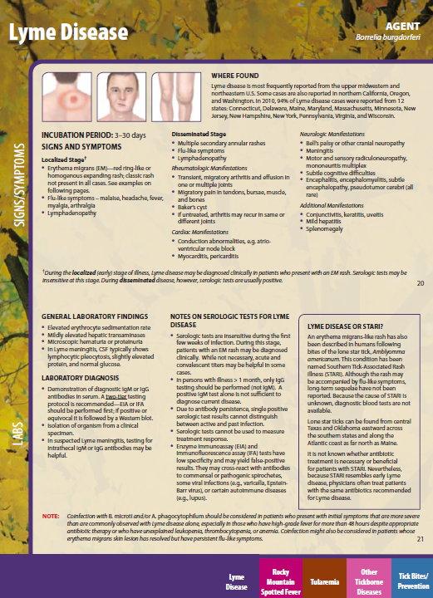

Centers for Disease Control and Prevention Resources for Clinicians
Includes information on diagnostics, treatments and learning tools.
- http://www.cdc.gov/lyme/healthcare/clinicians.html
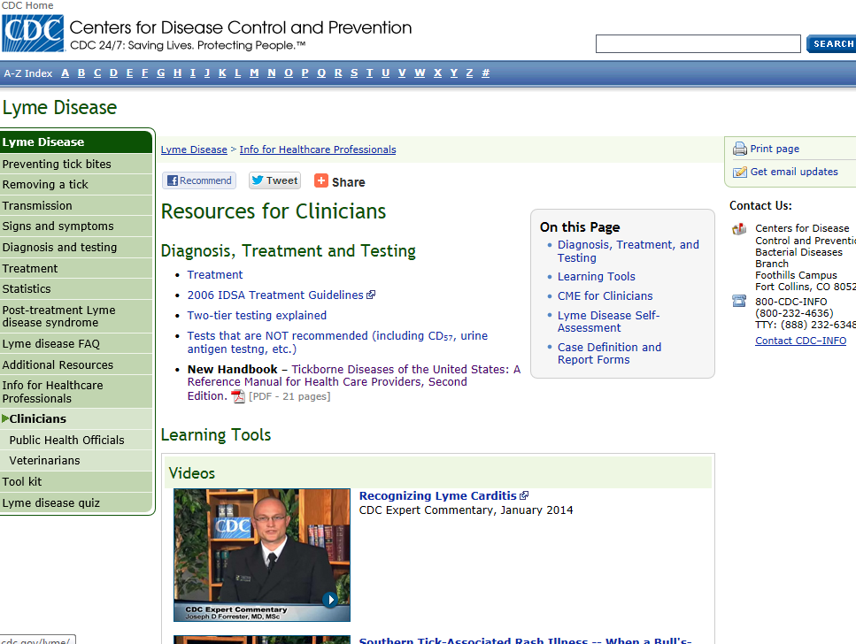

2006 IDSA Treatment Guidelines
- http://cid.oxfordjournals.org/content/43/9/1089.full
  - This is an updated set of guidelines that can be used by healthcare providers to assess, treat and prevent tick-borne diseases.

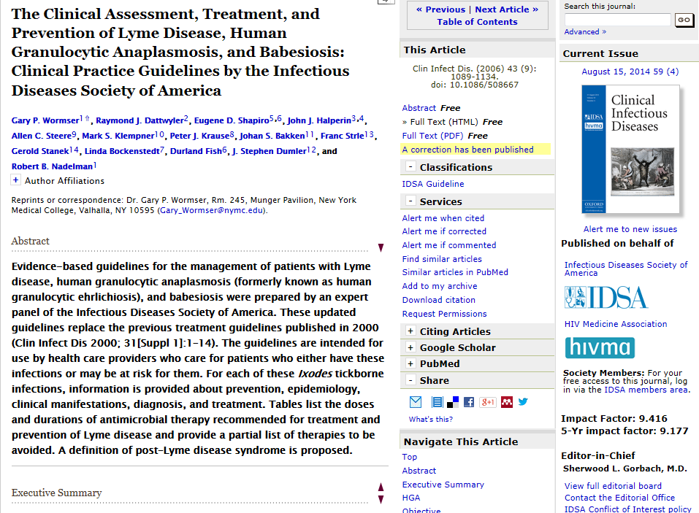

Continuing Medical Education for Clinicians
- As a service to clinicians, CDC has supported the development of an online CME Case Study Course on the Clinical Assessment, Treatment, and Prevention of Lyme Disease. This free, interactive course consists of a series of case studies designed to educate clinicians regarding the proper diagnosis and treatment of Lyme disease. Each case is accredited for .25 CME credits, for a maximum of 1.5 CME. There is no cost for these credits.
  - http://lymecourse.idsociety.org/
- The National Association of School Nurses presents an online course titled “Tick-borne Illness: Prevention, Assessment and Care” that focuses on clinical care of tick-borne diseases in school and camp settings. CNE is available.
  - http://bit.ly/1rCgUW5

Lyme Disease Self -Assessment
- From the American College of Physicians (ACP) Initiative on Lyme Disease--an online quiz containing six clinical scenarios regarding the evaluation and treatment of Lyme disease.
  - http://smartmedicine.acponline.org/content.aspx?gbosId=62

